COSC 310

Assignment 3

Drew Ingram, 16680076

4) I am not doing an A+ option

5)

Functional requirements of my project:

The program must…

Run on Windows: High priority, ~0 hours

Comprehend the user’s input, or understand what he/she said: High priority, ~29 hours

Take a user input: high priority, ~0 hours

Generate an output based on the user’s input: Low Priority, ~0 hours

Performance requirements:

The programs output must be a reasonable response to the user’s input: High priority, ~18 hours

The program must give varied responses to the user’s input: Medium priority, ~8 hours

The program must be able to carry on the conversation for 15 turns: Low priority, ~4 hours

Environmental Constraints:

The program must contain no code written by anybody but Drew Ingram

6) The program’s name is “Survivor”, for having survived the terrible situation it encountered.

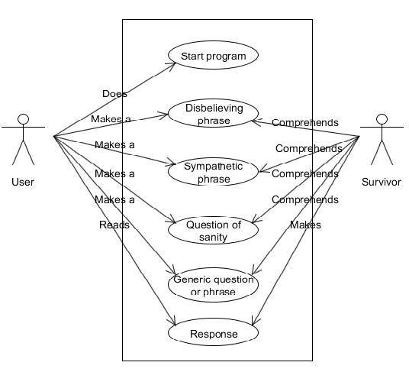

7)

